DEPT. OF ELECTRICAL & ELECTRONICS ENGINEERING

SRM INSTITUTE OF SCIENCE AND TECHNOLOGY, Kattankulathur – 603 203

|  |
| --- |
| Title of Experiment : 7. **Types of wiring: Stair case wiring** |
| Name of the candidate : SALONI PRAKASH  Register Number : **RA2011003011079**  Date of Experiment : **18-01-2021** |

|  |  |  |  |
| --- | --- | --- | --- |
| Sl. No. | Marks Split up | Maximum  marks (50) | Marks obtained |
| 1 | Pre Lab questions | 5 |  |
| 2 | Preparation of observation | 15 |  |
| 3 | Execution of experiment | 15 |  |
| 4 | Calculation / Evaluation of Result | 10 |  |
| 5 | Post Lab questions | 5 |  |
|  | **Total** | **50** |  |

Staff Signature

**PRE -LAB QUESTIONS**

**1. How does fluorescent lamp work?**

A **fluorescent lamp**  is a low weight mercury vapor lamp that uses fluorescence to deliver visible light. An electric current in the gas energizes mercury vapor which delivers ultraviolet radiation through the discharge process and the ultraviolet radiation causes the phosphor coating of the lamp inner wall to radiate visible light.

1. **What is the difference between fluorescent lamp and incandescent lamp?**

**Incandescent light** is a glowing white light produced by heat. It is often viewed as more

"natural" than fluorescent light and has been preferred for home use even though it is not as energy-efficient as fluorescent light. An incandescent light bulb works by heating a filament in the bulb.

**Fluorescent light** is a bright light produced by electricity flowing through a tube filled with ionized gas. Fluorescent light bulbs are more energy-efficient than incandescent bulbs. They take time to reach their full brightness and tend to be slightly more expensive than incandescent bulbs but last much longer. There is some concern about the fact that they contain mercury.

1. **What are the advantages of fluorescent light bulbs?**

Energy efficient- so far, the best light for interior lighting

Low production cost (of tubes, not of the ballasts)

Long life of tubes

Good selection of desired color temperature (cool whites to warm whites)

Diffused light (good for general, even lighting, reducing harsh shadows)

1. **What is the voltage required to start a fluorescent lamp?**

**Fluorescent tubes** and lamps require 200 to 600 V for starting and running illumination.

1. **What is the function of starter in a fluorescent lamp?**

Fluorescent starters or glow starters are used to help fluorescent tubes and lamps ignite in the initial starting stage of their operation. Simply put, fluorescent starters are a timed switch. The switch opens and closes until the fluorescent tube 'strikes' and lights-up.

|  |  |
| --- | --- |
| **Experiment**  **No.5 Date :**  **02-11-2020** | **STAIRCASE WIRING** |

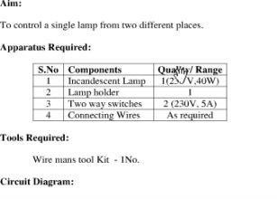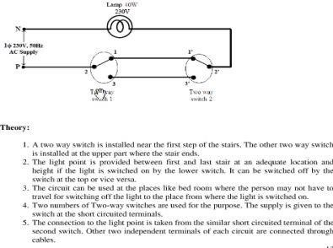

**Procedure:**

1. Give the connections as per the circuit diagram.
2. Verify the connections.
3. Switch on the supply.
4. Verify the conditions

**Tabulation:**

|  |  |  |
| --- | --- | --- |
| **Positions of Switches** | | **Condition of Lamp** |
| **S1** | **S2** |
| ON  OFF  ON  OFF | ON  OFF  OFF  ON | OFF  OFF  ON  ON |

**Circuit Diagram:**  **Result:**

It can be concluded that a lamp can be operated two ways from two different location of switches but they should be similar like 1 1`or 3 3`.

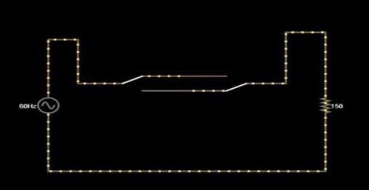

# POST LAB QUESTIONS

**1. What is the use of staircase wiring?**

* The main purpose of two-way switching connection is to connect and control AC appliances and equipments from two separate locations.
* It is mostly used in staircase wiring where a light bulb can be controlled (Switch ON/ Switch OFF) from different places, no matter if you are in the upper or lower portion of the stair. Also, it does not depend on the switches position as well. You just have to press the switch button to OFF / ON to perform the switching operation.
* It is also used in rooms having large areas which have two entry and exit gates. ❖  It is used to control any electrical (AC or DC) appliance or equipment like fan, light bulbs etc. from two different places.

1. **Why is choke used in fluorescent lamps?**

The purpose of the choke is to provide a very high voltage initially between the filaments (across the two ends of the tube light). Again, once the gas in the tube is ionized the choke provides a low voltage. A choke is a coil of wire.

Fluorescent tubes/lamps are filled with mercury vapor. They use electric charge to excite mercury atoms in order to produce ultraviolet light. A glow starter or commonly known as starter is used in the tube light circuit to provide an initial current to filaments of the tube light.

1. **What is the purpose of magnetic ballast in fluorescent lamps?**

The magnetic ballast uses a magnetic transformer of copper windings around a steel core to convert the input line voltage and current to the voltage and current required to start and operate the fluorescent lamps. Capacitors are added to assist lamp starting and power factor correction.

1. **Compare electronic ballast and magnetic ballast?**

**Electronic Ballasts**

Electronic ballasts alter the flow of electricity in the light bulb by using a series of induction coils that are separated from one another. In contrast, magnetic ballast uses 1 induction coil and not a series.

Another difference is that electronic ballasts change the frequency of the electrical current without changing the voltage. While magnetic ballasts in fluorescent lamps work at a frequency of 60 hertz, electronic ballasts greatly increase that frequency to 20,000 hertz.

**Magnetic Ballasts**

Since magnetic ballasts are not as sophisticated as electronic ballasts and can be problematic, they are being replaced by the electronic versions. Magnetic ballasts are found in the light socket in between the plug for the light bulb and the power cord.

In magnetic ballasts, current flows through coils of copper wire before moving on to the light bulb. Most of the current gets caught in the magnetic field it generates, with only small increments moving on to the light bulb.

**5. List out the advantage of staircase wiring.**

**Advantages of Using Staircase Wiring:**

* Easy to control appliances from various points.
* Faster control than a single switch.
* Highly Efficient for larger places. ❖ Living Comfort can be increased. ❖ Electricity can be saved.